Module 12

#1. Plotting magnetic data

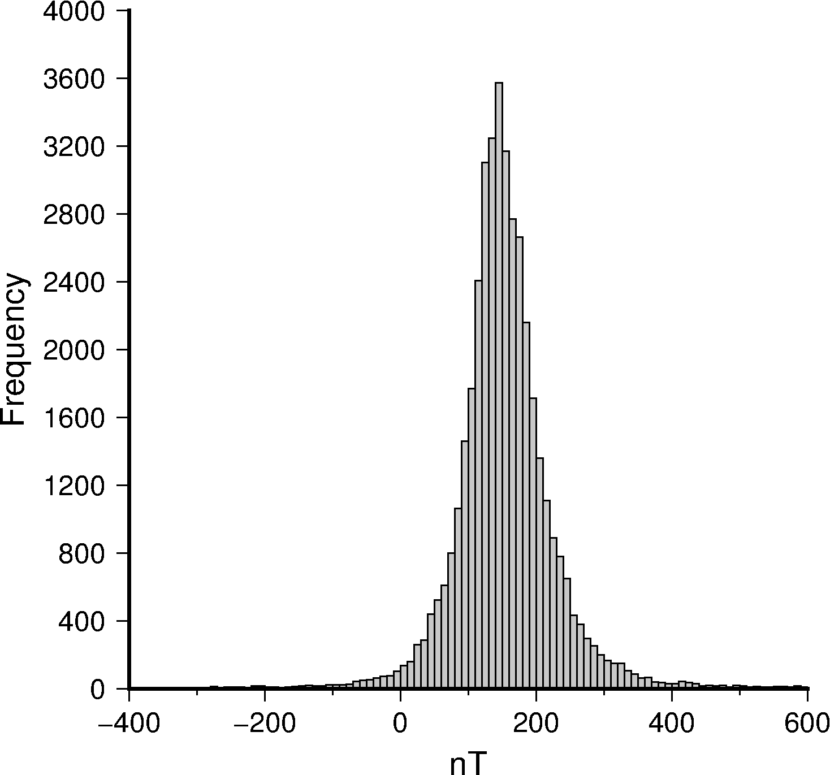

Figure 1-1: Histogram of the magnetic data from the San Rafael volcanic field.

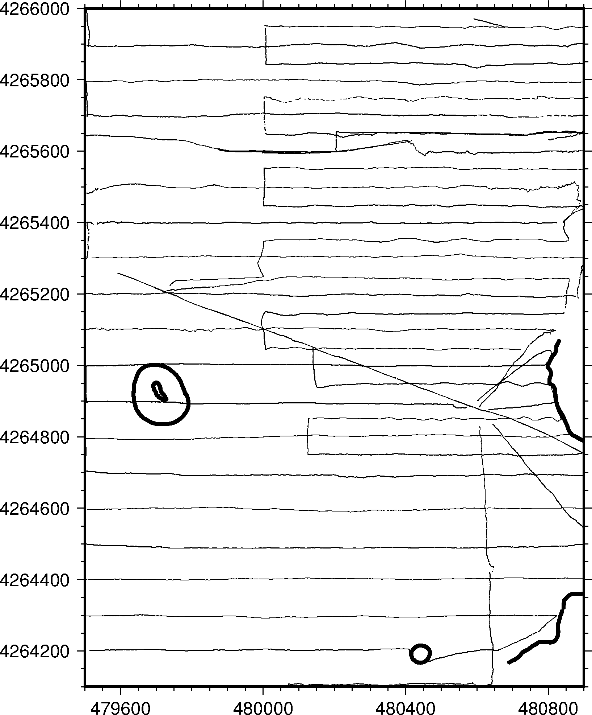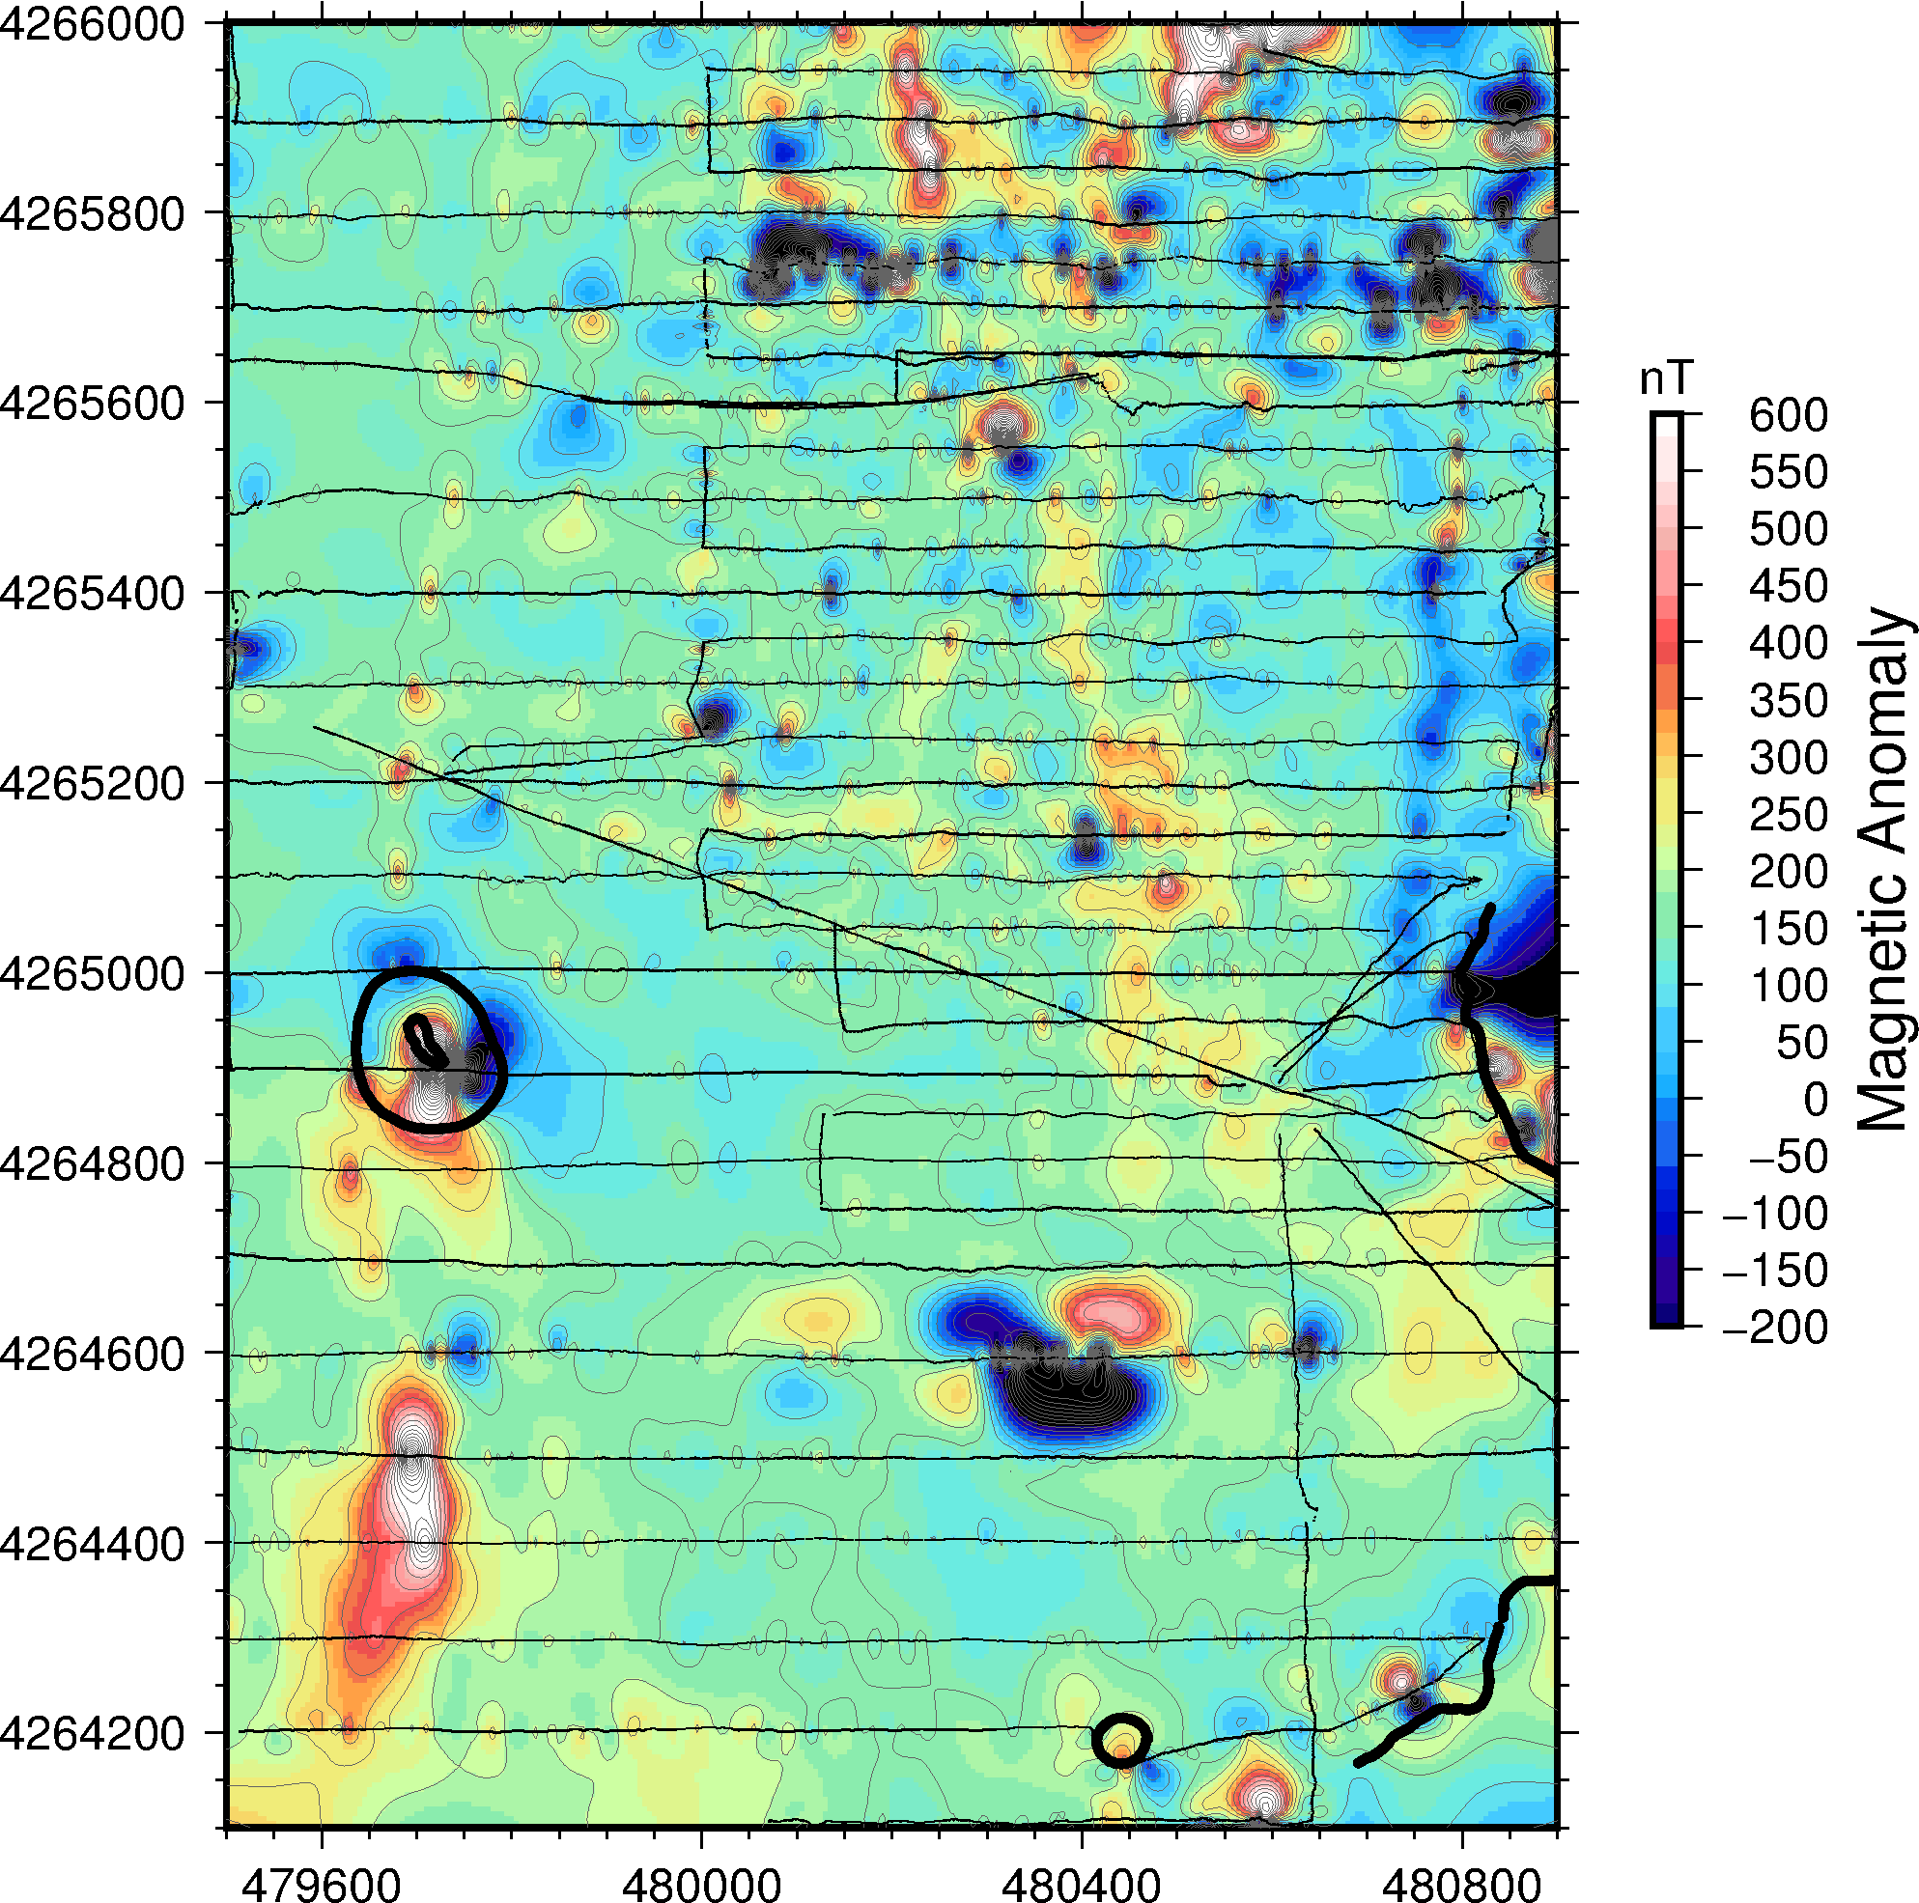

Figure 1-2: Plot of unfiltered map of points collected (left) and the resulting magnetic map (right). The anomalous data in the South with an abnormal low point is to be removed as well as a line of anomalously low data in the North trending E-W.

B

A

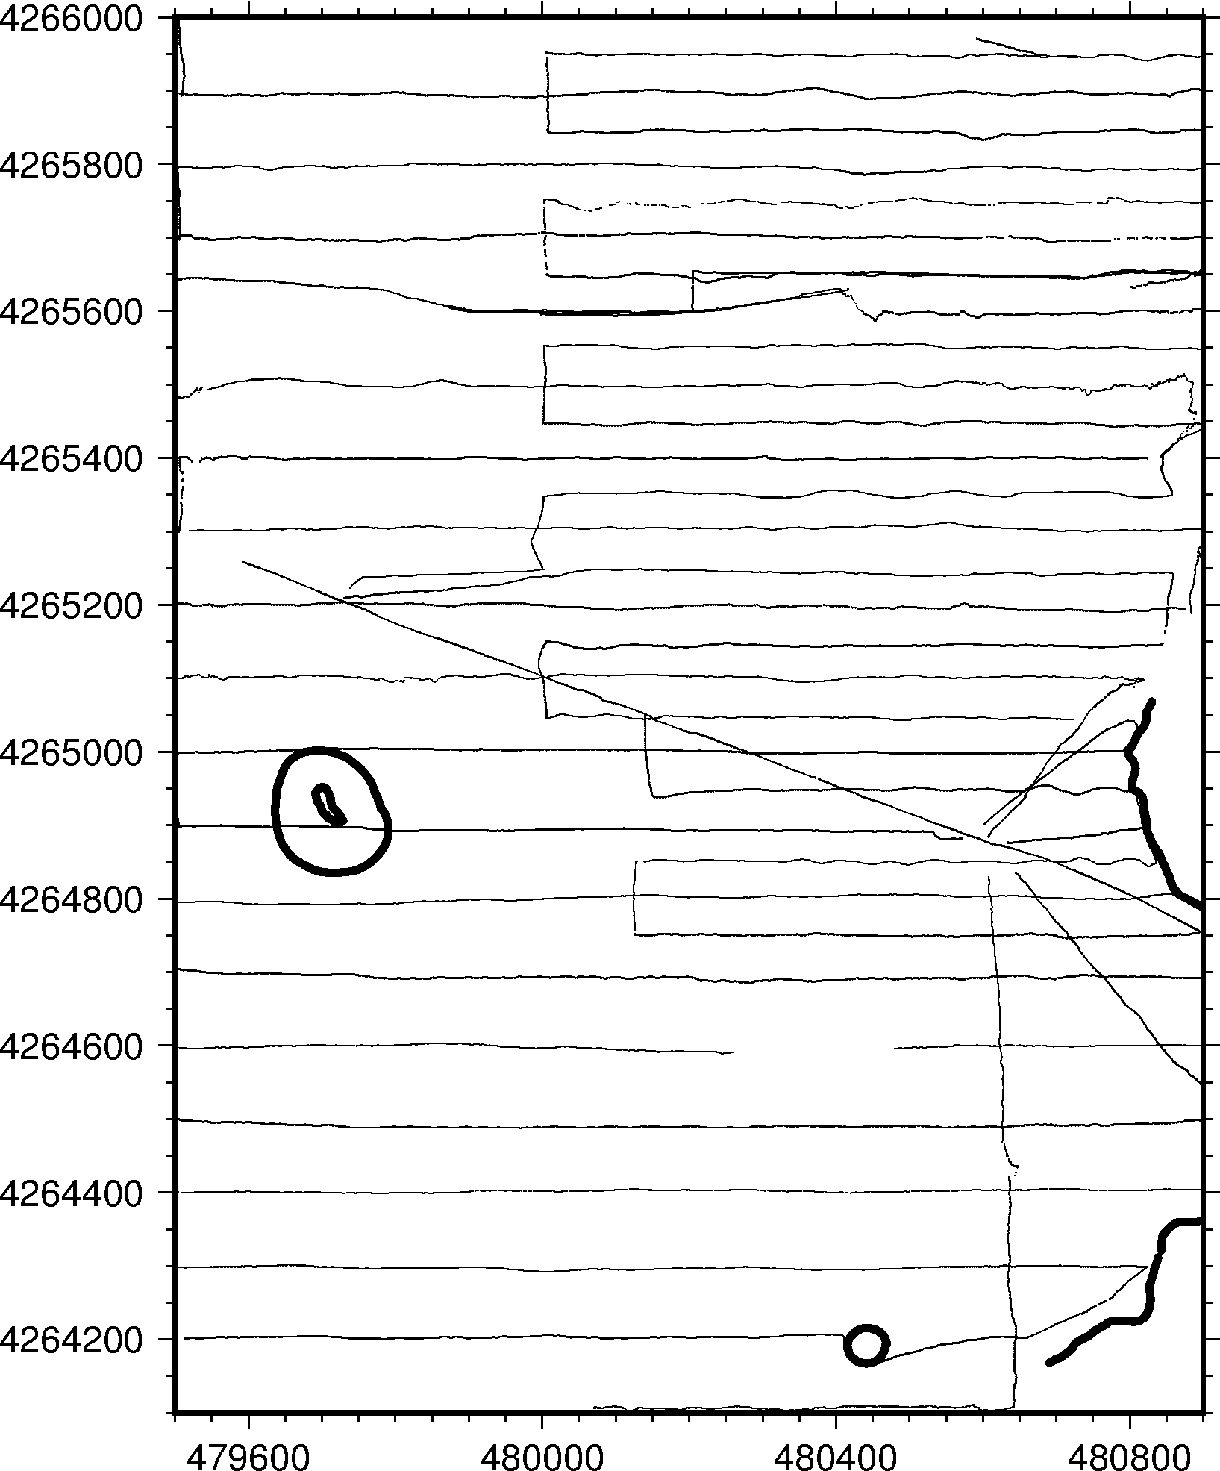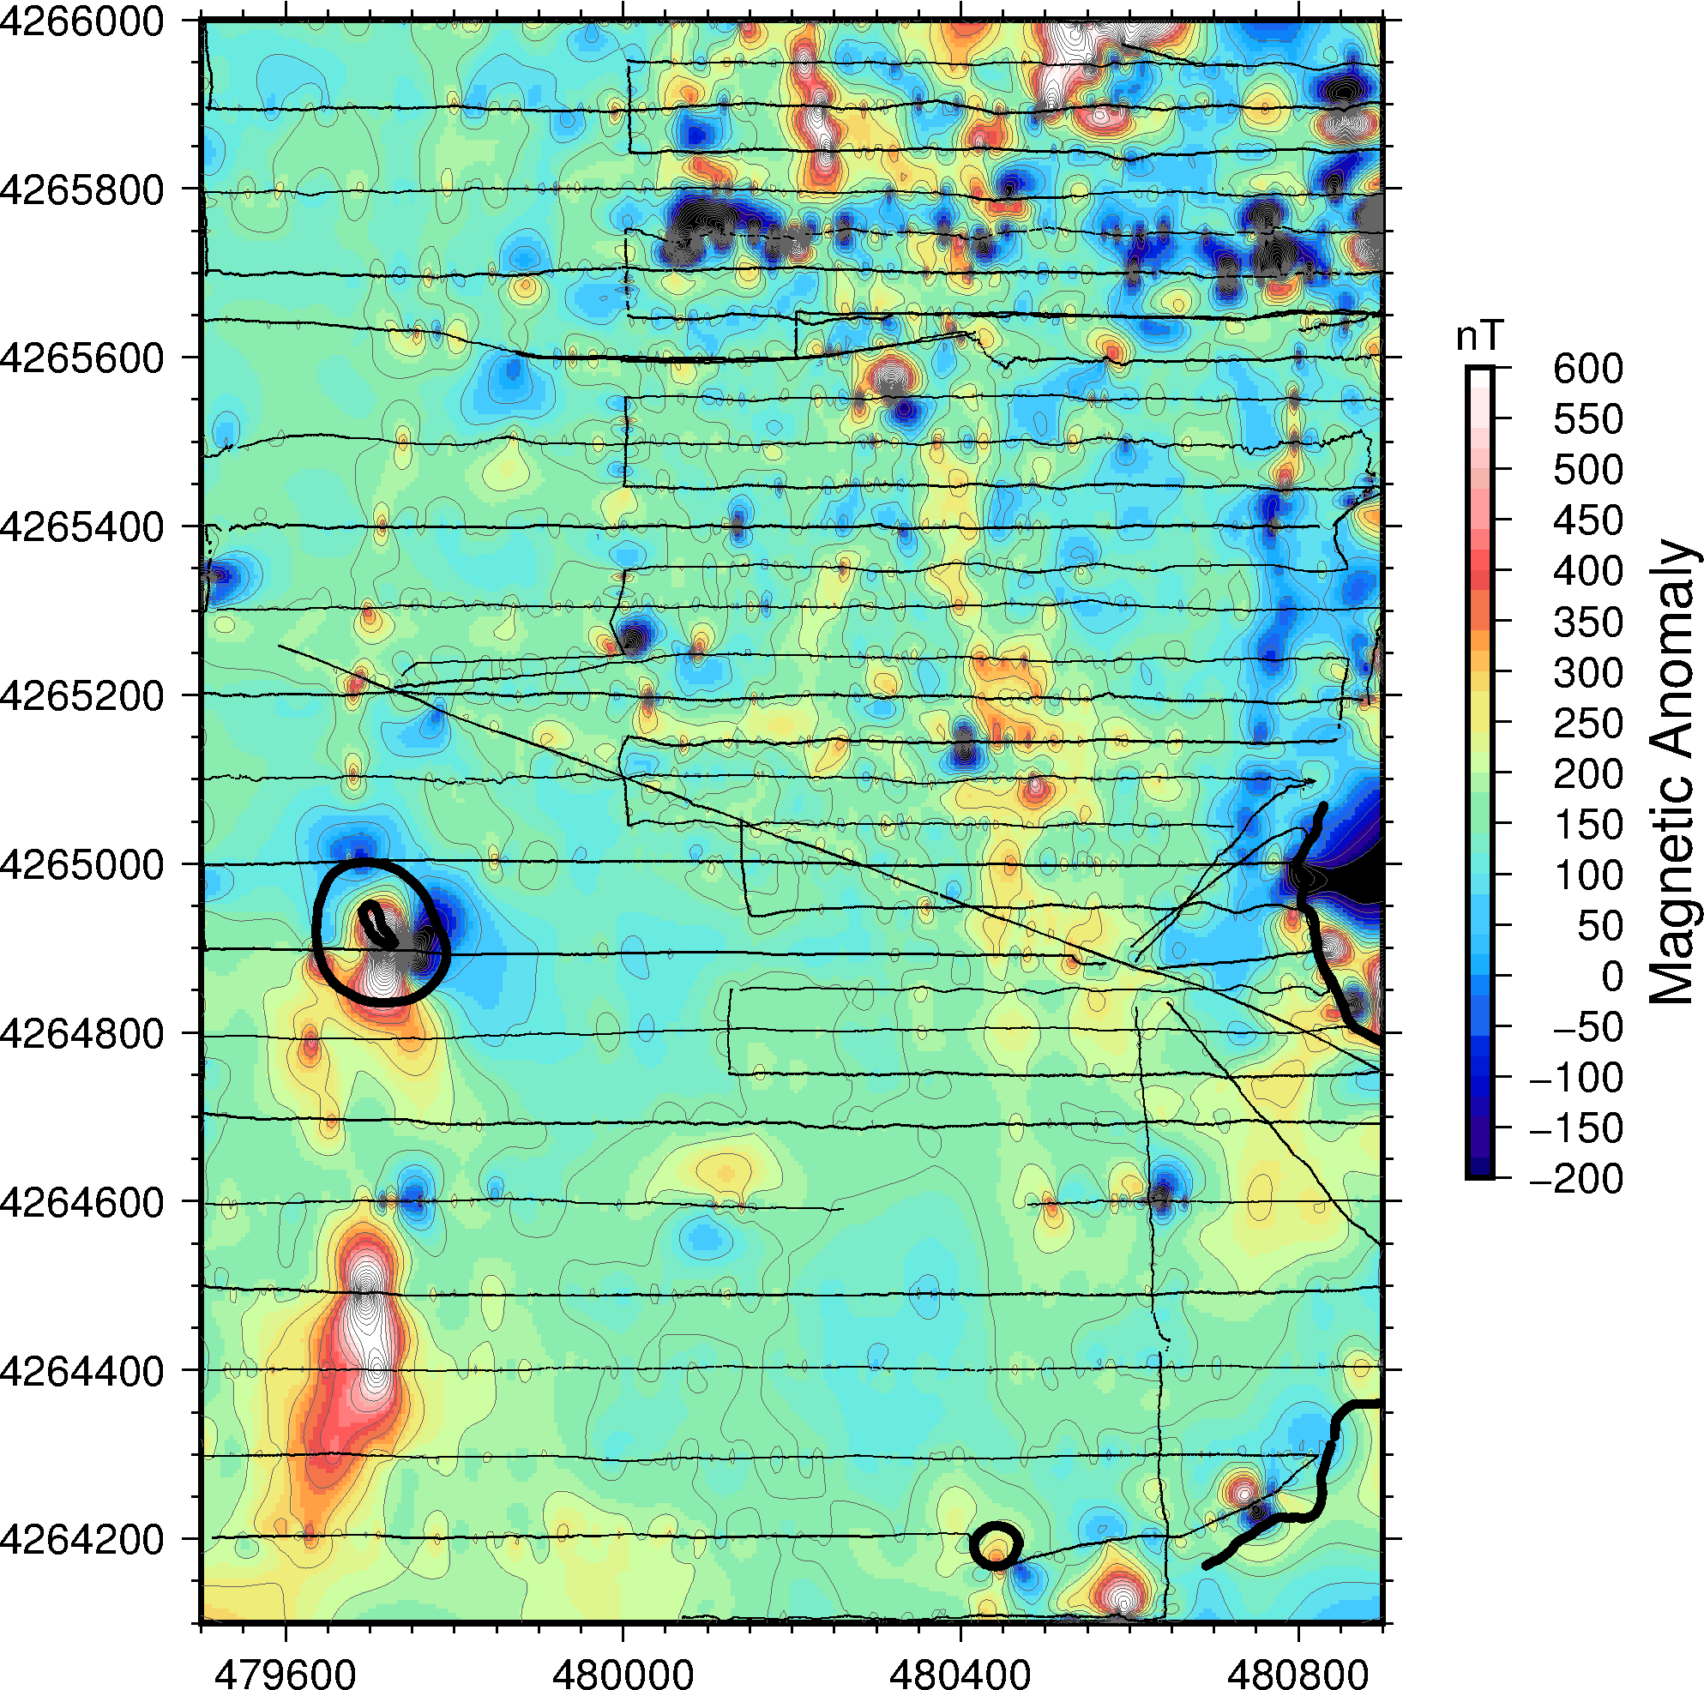

Figure 1-3: Plots of filtered data locations (left) and contoured magnetic data (right). The data has been smoothed in the South by the removal of the large anomalous low, although the filtering script did not remove the anomalous line in the North. The prominent anomalies are the NNW trending highs (A) and the N-S trending pair (B).

#2. Upward continuation

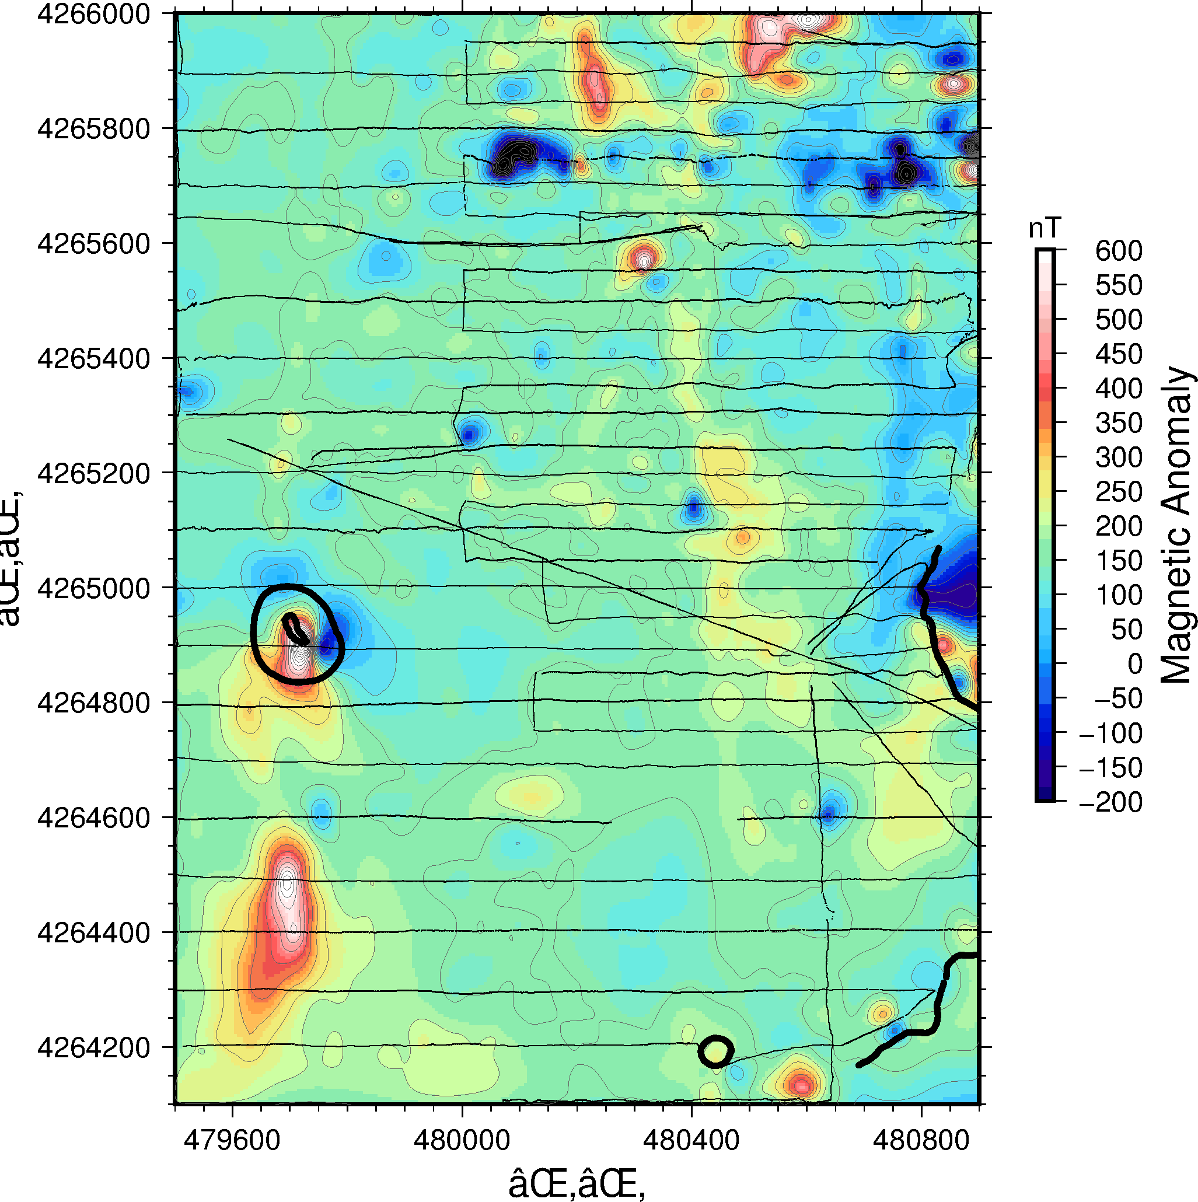

Figure 2-1: 10m upward continuation of the data plotted in Figure 1-3. Many of the smaller, short wavelength features have been removed, leaving the more N-S and NNW trending features as the prominent anomalies

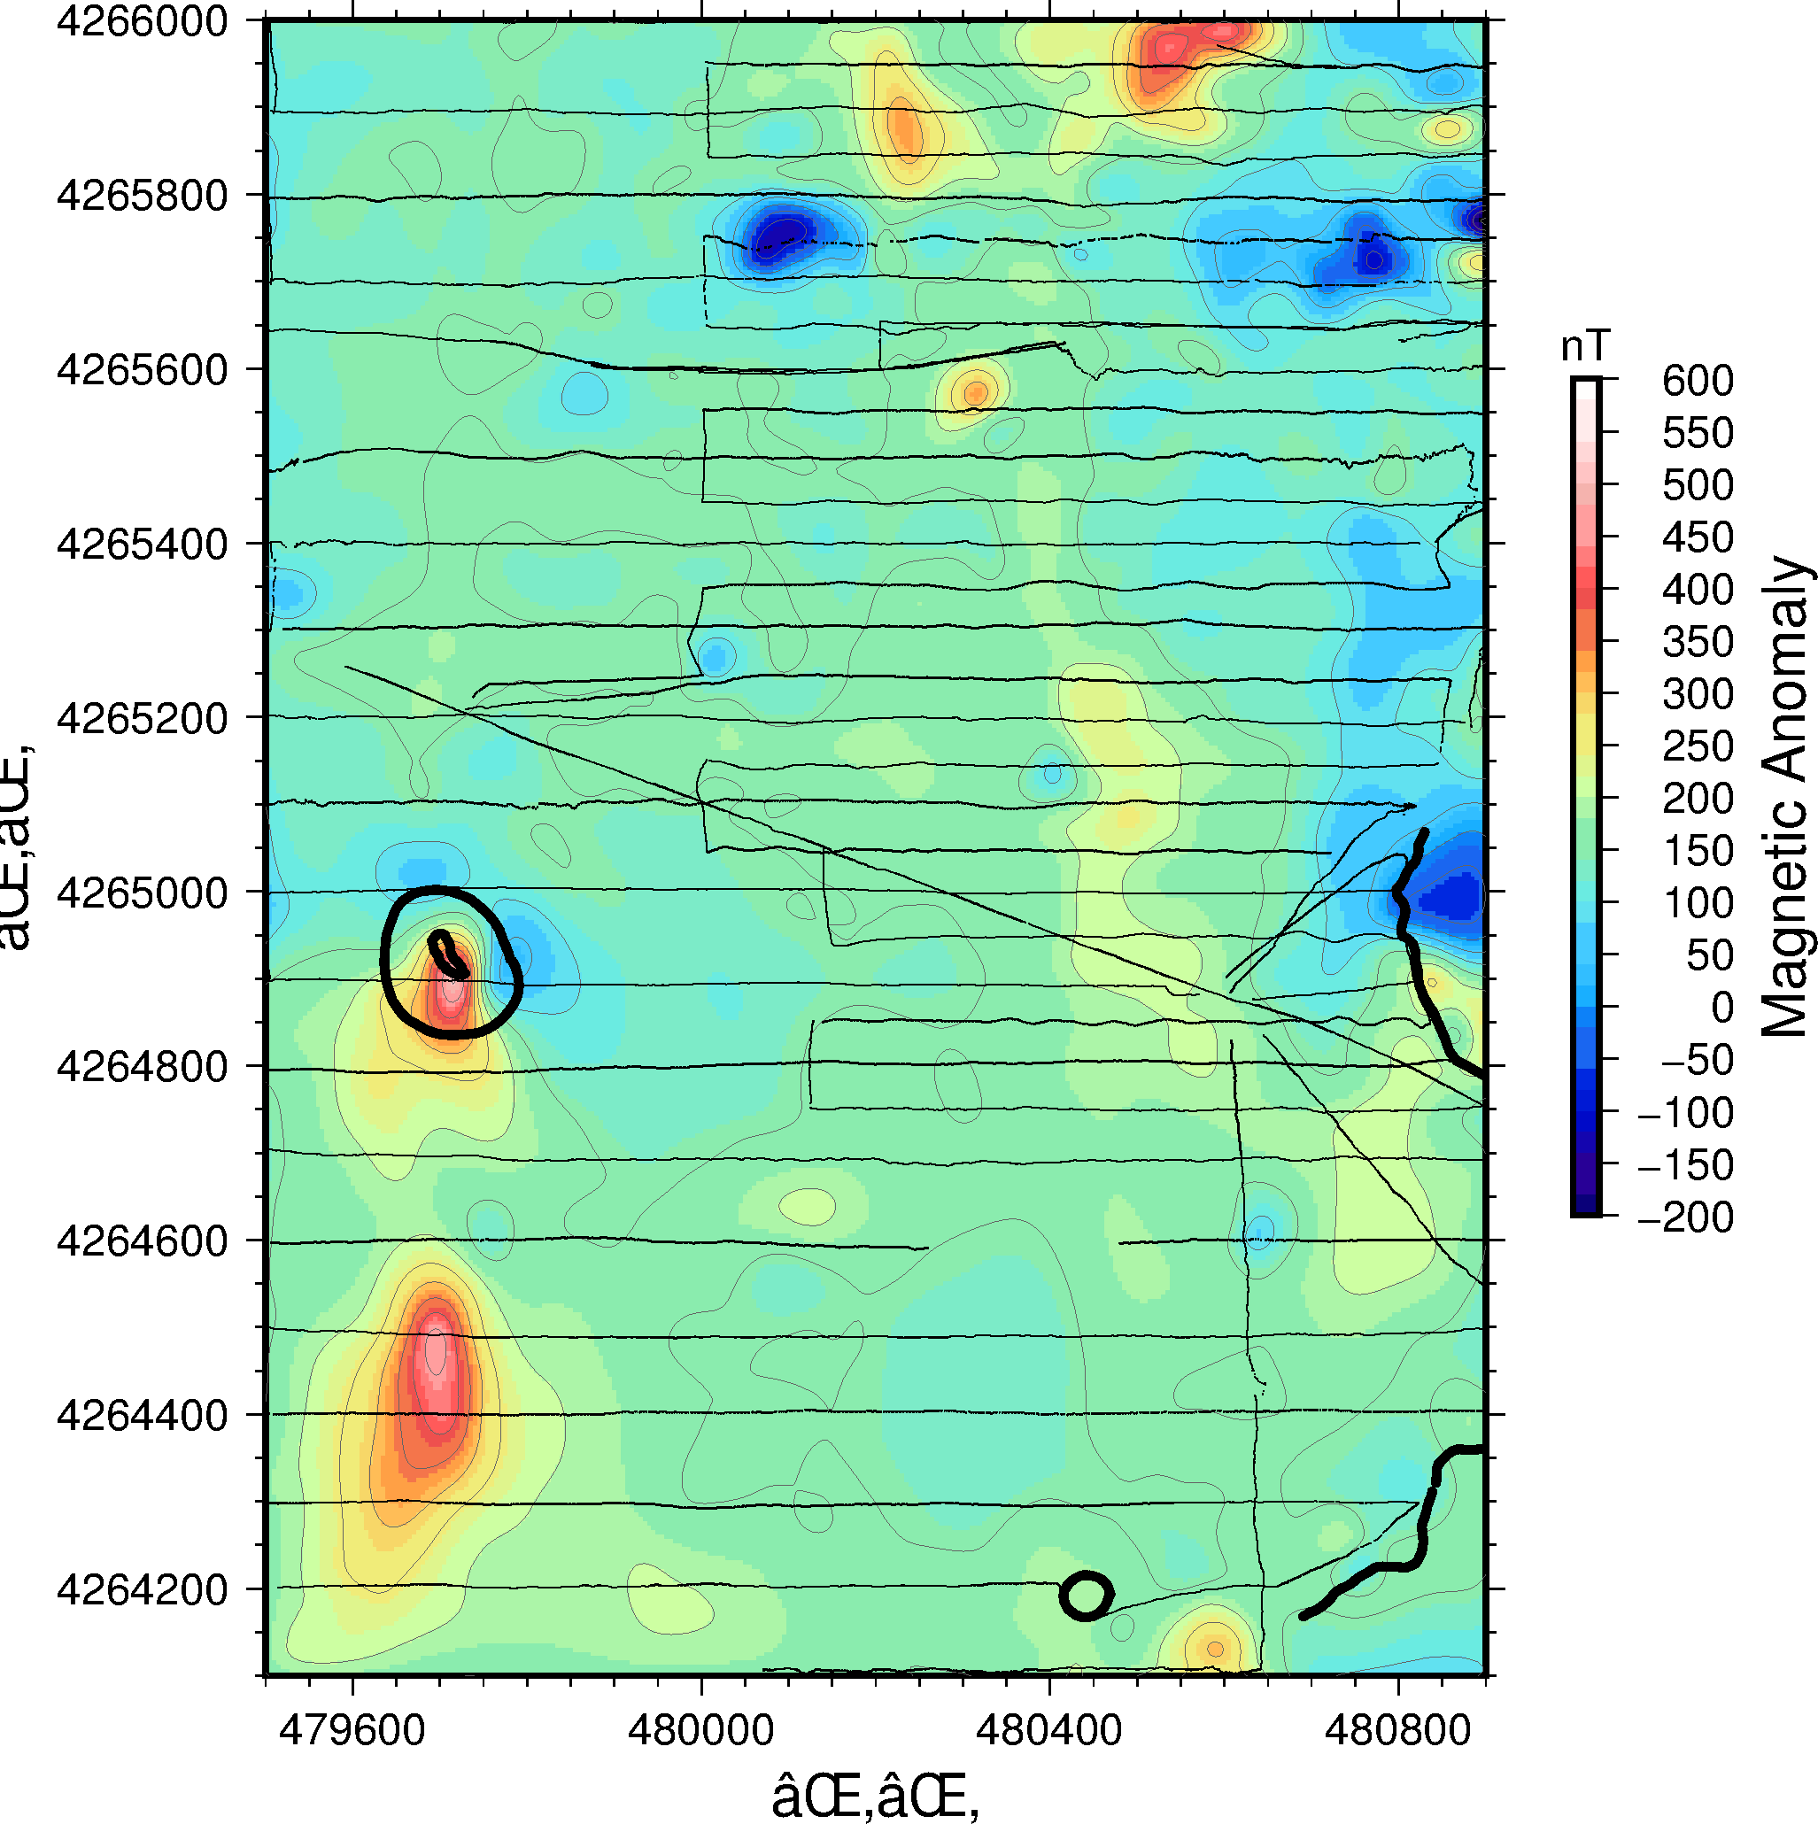

Figure 2-2: 25m upward continuation of the data plotted in Figure 1-3. Only the few larger, long-wavelength anomalies remain, and some of the NNW trending anomalies have been reduced or lost.

#3. Reduction to pole

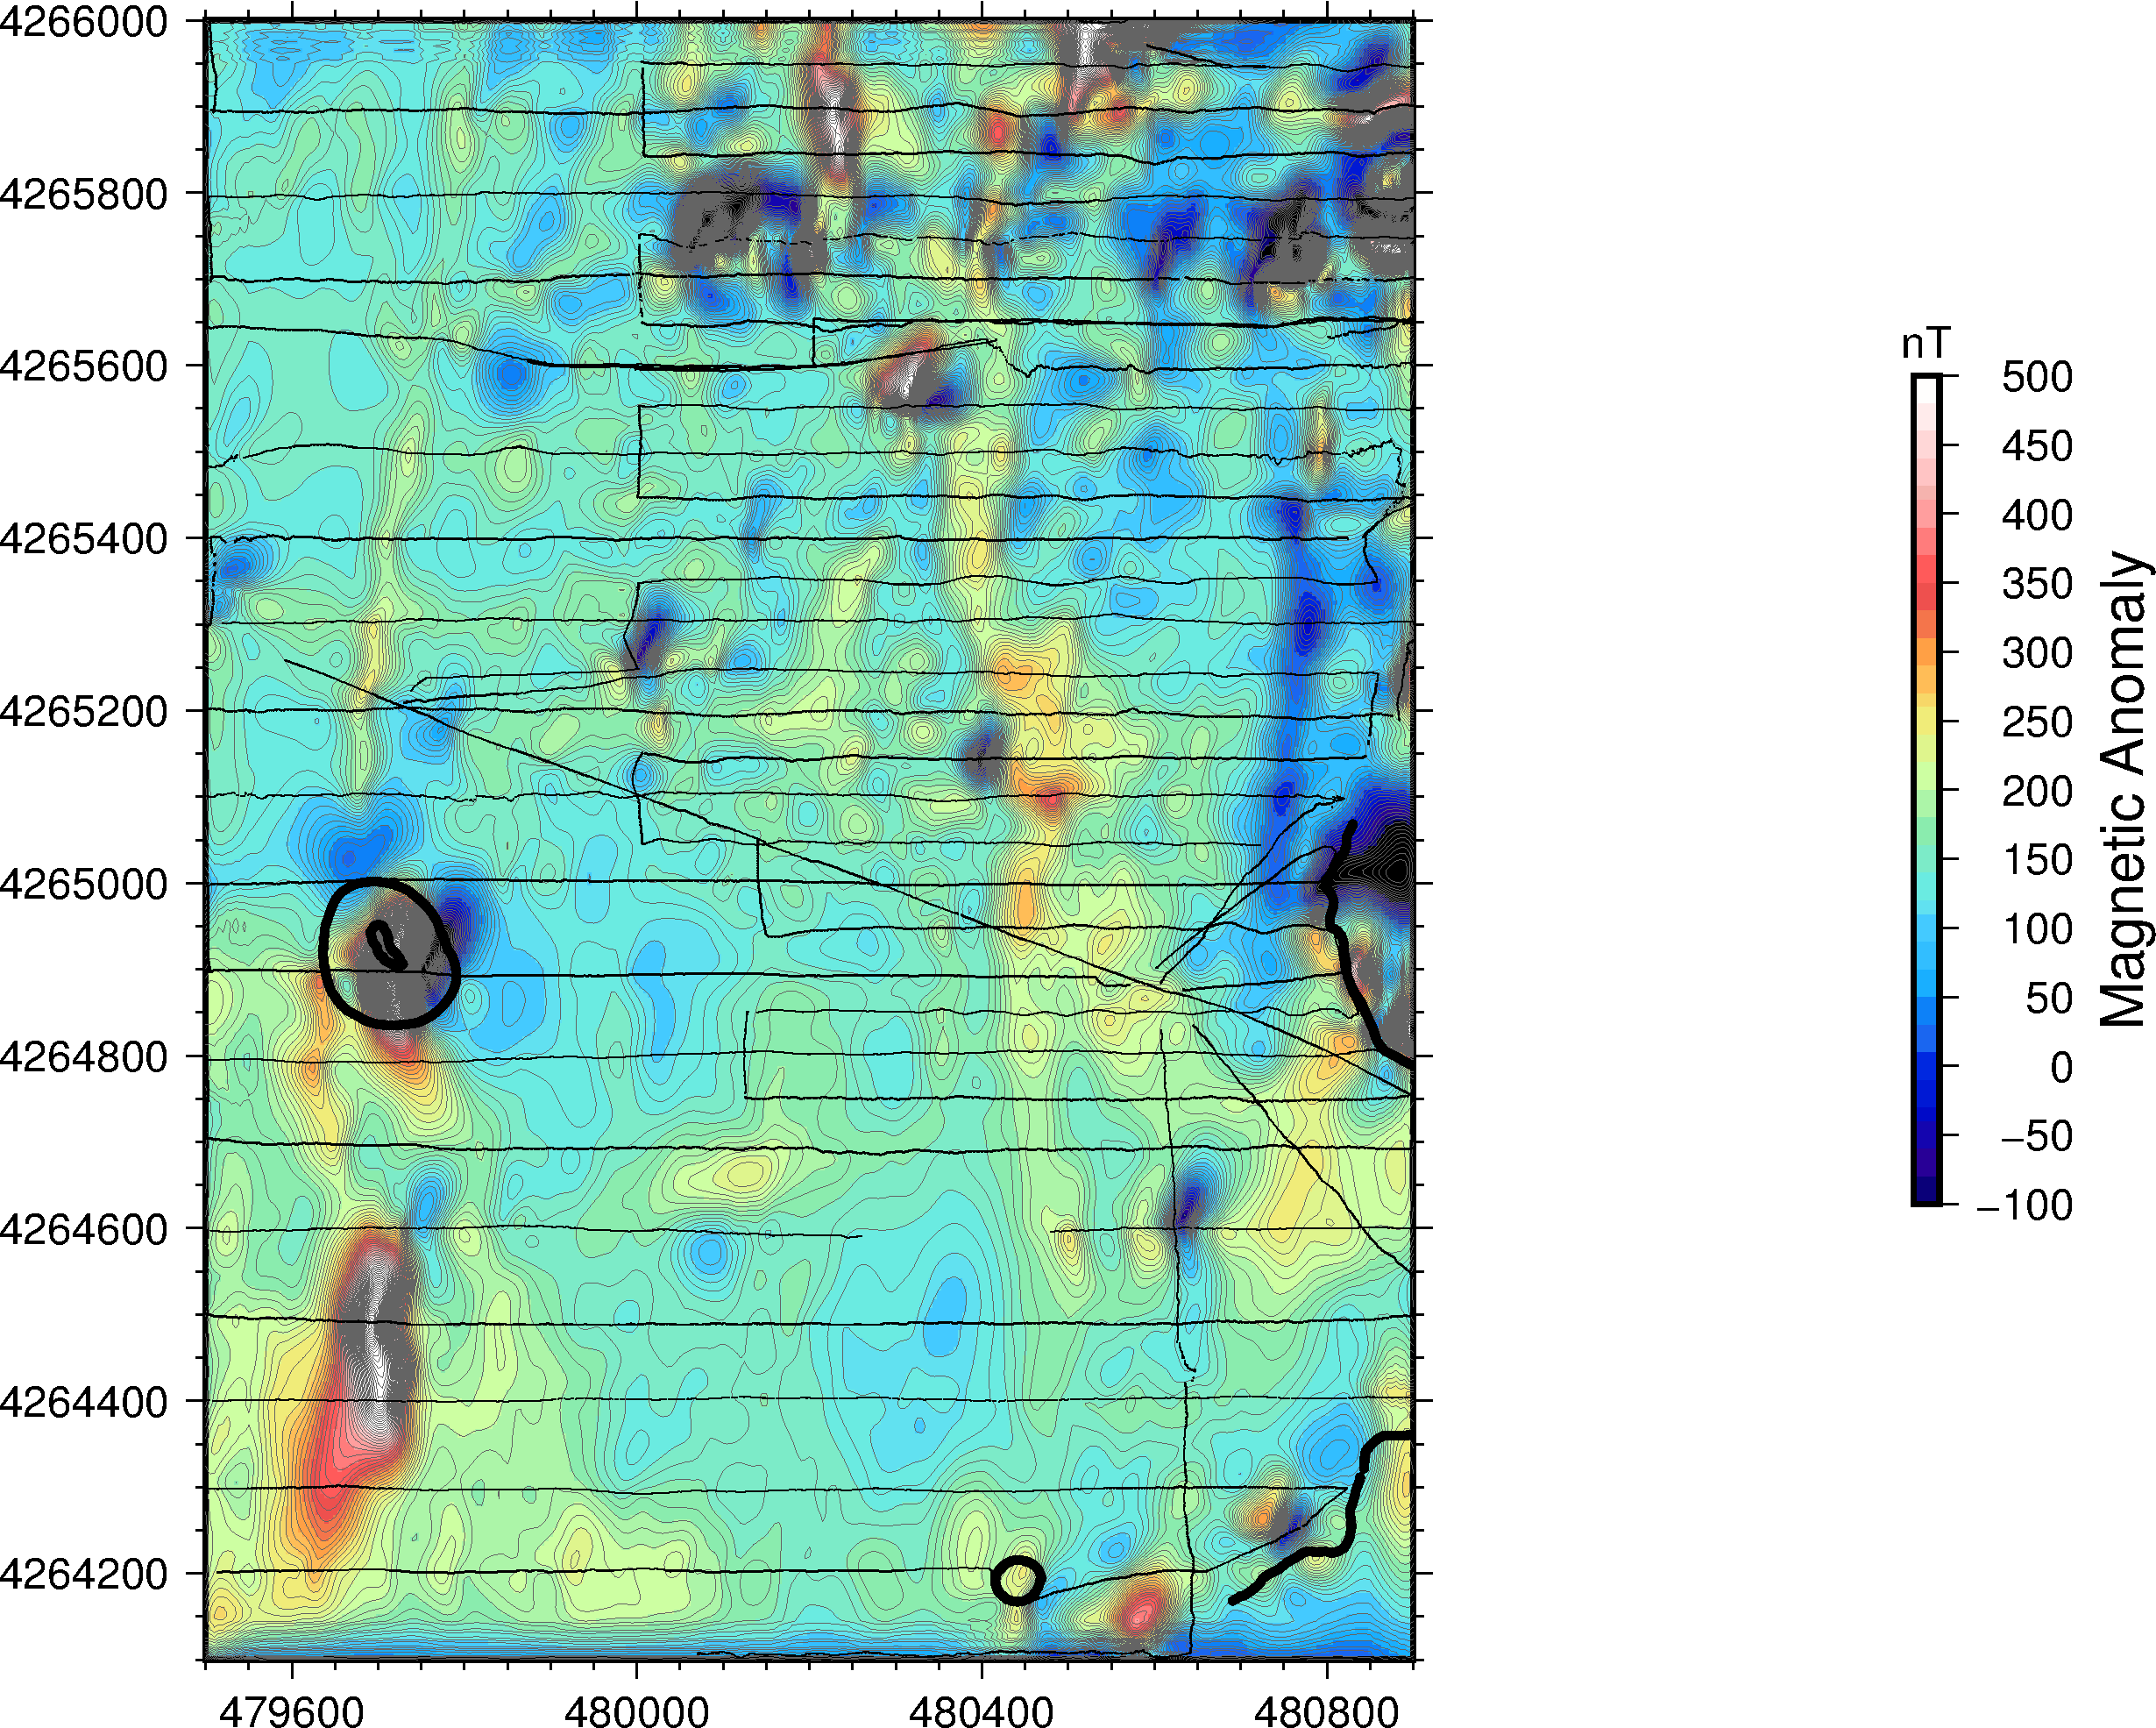

Figure 3-1: Reduction to pole of Figure 1-3 with a 0 degree declination. The anomalies are lined up closely with their position before reduction to pole due to the steep inclination of the area.

A

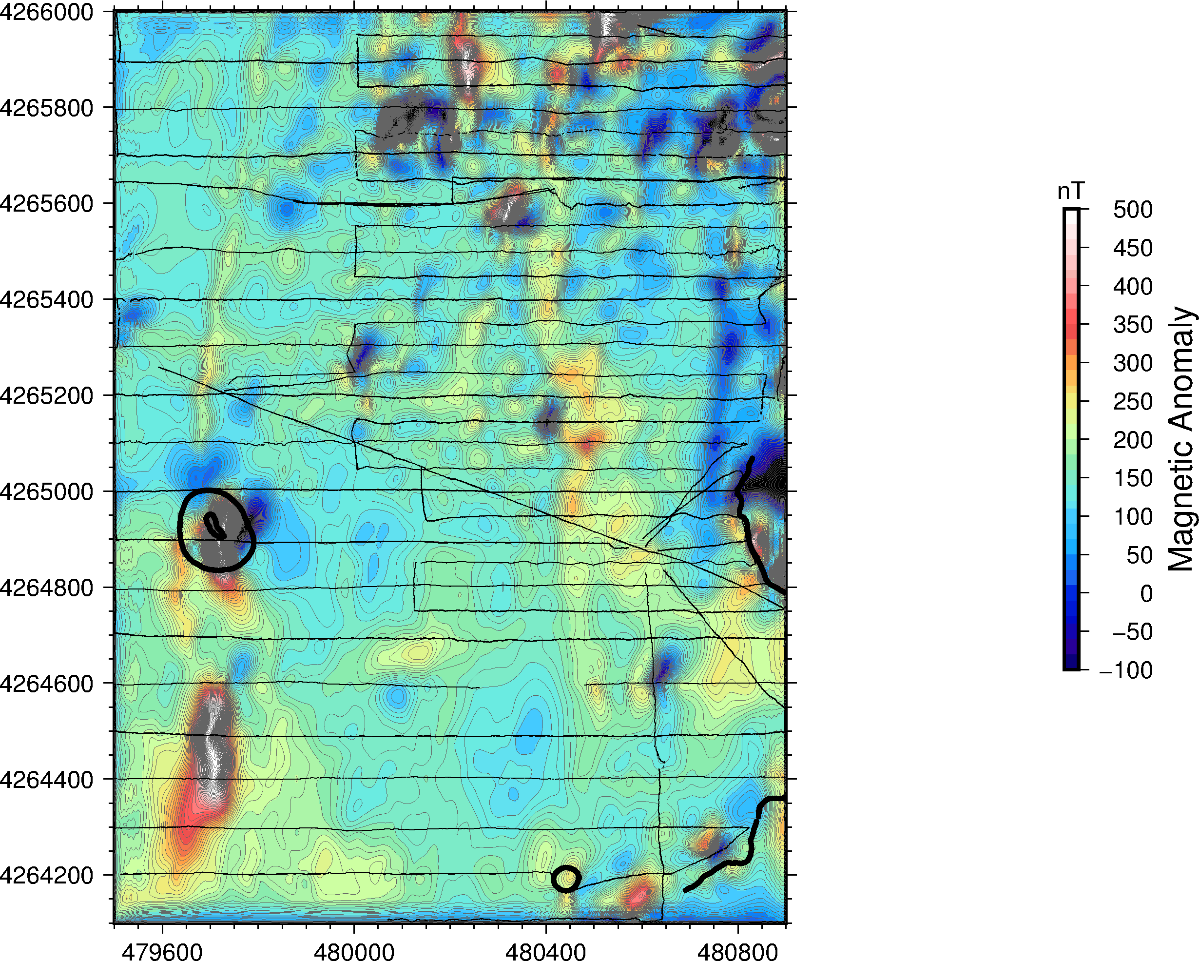

Figure 3-1: Reduction to pole of Figure 1-3 with a 13 degree declination, the correct declination for the area of the map. This change in declination has shifted the previously NW anomalies (A) to a more NNW orientation and shifted all of the anomalies slightly to the NNE

B

#4. The NNW Trending magnetic highs (A) have relatively low amplitude towards the South and higher amplitude towards the North. This is likely either due to a change in composition or depth, with the North either being closer to the surface or having a higher ferromagnetic or ferromagnetic composition. They could also have a higher remnant magnetization to the North that contributes to their larger anomaly amplitude. These anomalies could be associated with dikes or a series of smaller cinder cones. The larger anomalies in the South with a nearly perfect N-S orientation (B) are likely to be from dikes with high ferrimagnetic or ferromagnetic composition. Looking at Figures 2-1 and 2-2, the anomaly remains strong through upward continuation, indicating that has a longer wavelength compared to the other anomalies on the map. This feature also has a very large remnant magnetization as the anomaly reaches around 600 nT, being high compared to induced magnetization.